




Supervisor: Tran Minh Hoa
Curriculum: ACCP i7.1
Semester: 3 - HDSE
Batch Code: 0906E
Student : Tran Phan Quoc Hai
Nguyen Huu Sang
Pham Hong Tam
Nguyen Duc Viet





This is to certify that
Mr. TRAN PHAN QUOC HAI
has successfully designed and
developed
Online Shopping Cart
Submitted by:

TRAN PHAN QUOC HAI
Date of Issue: 08/12/2010
Authorized Signature: ___________

This is to certify that
Mr. NGUYEN HUU SANG
has successfully designed and
developed
Online Shopping Cart
Submitted by:

NGUYEN HUU SANG
Date of Issue: 08/12/2010
Authorized Signature: ___________

This is to certify that
Mr. PHAM HONG TAM
has successfully designed and
developed
Online Shopping Cart
Submitted by:

PHAM HONG TAM
Date of Issue: 08/12/2010
Authorized Signature: ___________

This is to certify that
Mr. NGUYEN DUC VIET
has successfully designed and
developed
Online Shopping Cart
Submitted by:

NGUYEN DUC VIET
Date of Issue: 08/12/2010
Authorized Signature: ___________

Table of Content

Content Page
1 . Problem Definition 5
2 . Customer Requirement Specification (CRS) 5
3 . Project Plan 6
4 . Site Map 7
5 . Use Case 8
5.1. System
5.2. Admin
5.3. Employee
5.4. Registered Customer
5.5. Unregistered Customer
6 . Process Flowchart 9
6.1. Login 9
6.2. Change Password
6.3. Create
6.4. Update
6.5. Delete
6.6. Create Product
6.7. Update Product
6.8. Delete Product
7 . Entity Relationship (E-R Diagram) 10
8 . Table Design
9 . Program Design
10 . Document Design

1. Problem Definition:

Arts is a stationary shop that sells arts, gift articles, greeting cards, dolls, files, hand bags, wallets, and as well some of the beauty products, etc…. As there is a lot of demand for the greeting cards, gift articles, hand bags, etc…. and in this busy world where one can hardly find time to go out for shopping and with the emerging new technologies where one can purchase products by placing an order through online by sitting at home/office either by credit cards or by VPP or through Cheque or through DD

2. Customer Requirement Specification/Overview

Client/Project Undertaken: Online Shopping Cart

System Study:

2.1. List of inputs to the system.

2.2. List of outputs expected from the system.

2.3. Overview of processes involved in the system.

2.4. Data Constraints/Triggers/Validation tables.

  - Hardware and software required for implementing the project.

  - Hardware
- A minimum computer system that will help you access all the tools in the courses is a Pentium 166 or better
- 128 Megabytes of RAM or better
- OS: Windows 2000 Server (or higher if possible)

  - Software
- Microsoft SQL Server 2005
- Microsoft Visual Studio 2005
- Microsoft .NET 3.0

3. Project Plan

3.1. Project Details

Name of the Client:

- Date of the Project Plan: 08/11/2010

- Our understanding of the client organization

3.2. Project Initiation/Requirement Documents

3.6. Quality Plan
- Review Activities (review meeting participants, and frequency).

- Testing Activities (Unit Test Plans, Integration Testing and Functionality Testing).
Group will do something such as test links, test function every meeting.
- Backup and recovery strategies (in case of disk crash and network failures).
After weekly, group will backup source code, database.

4.Site Map

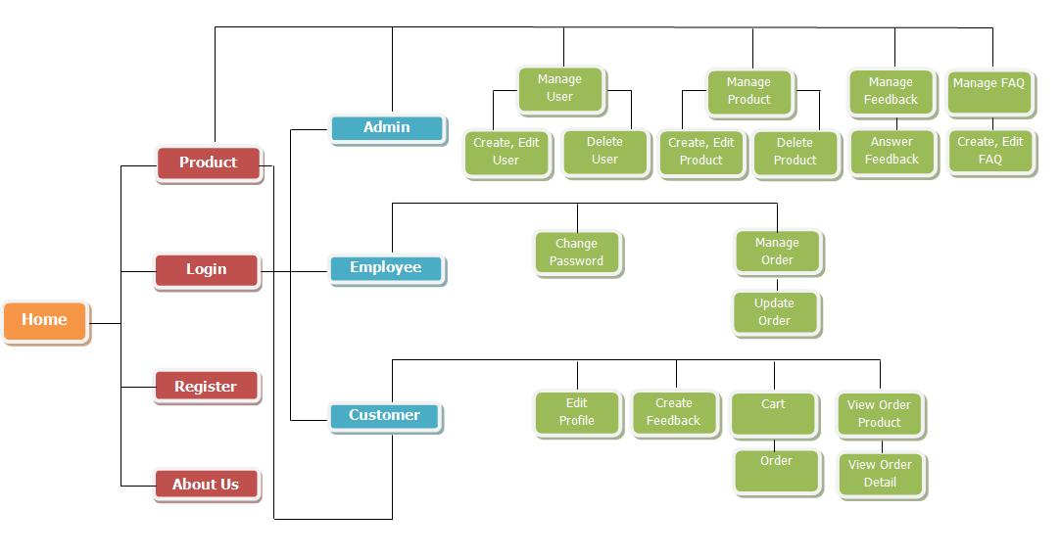

5.Use Case
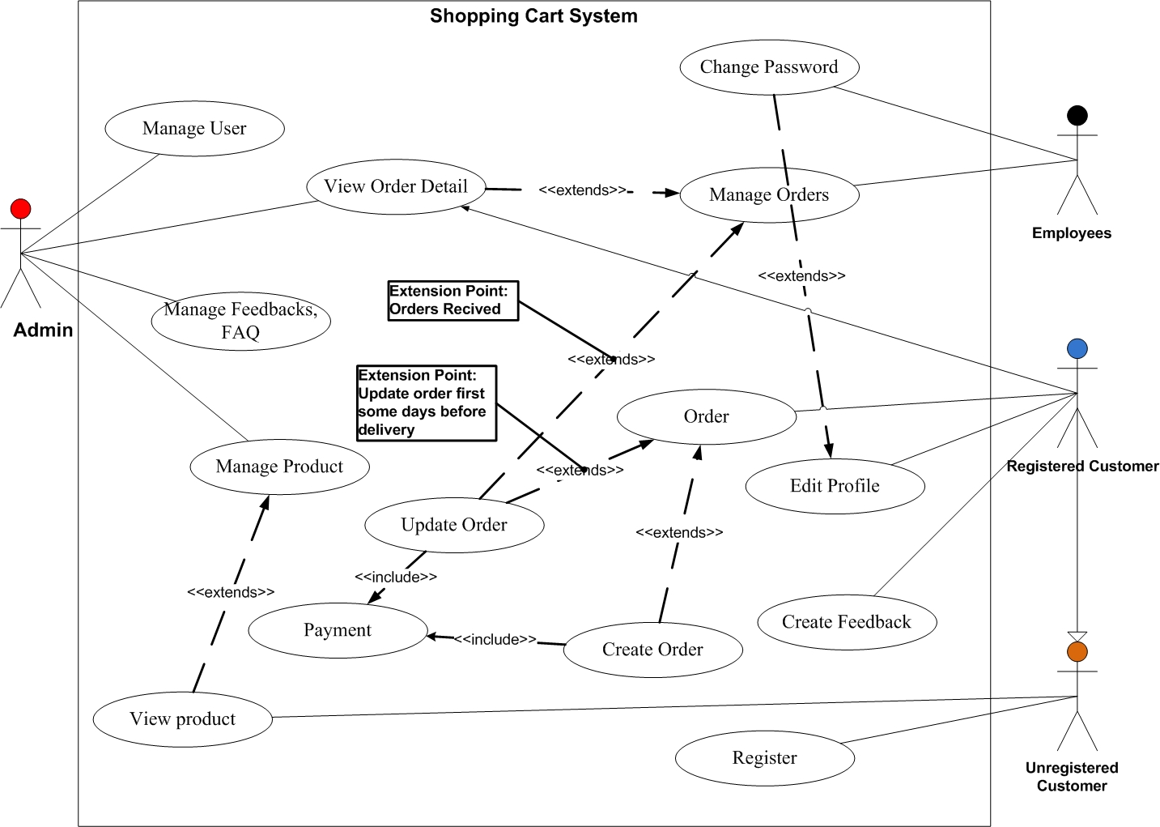
5.1 System:

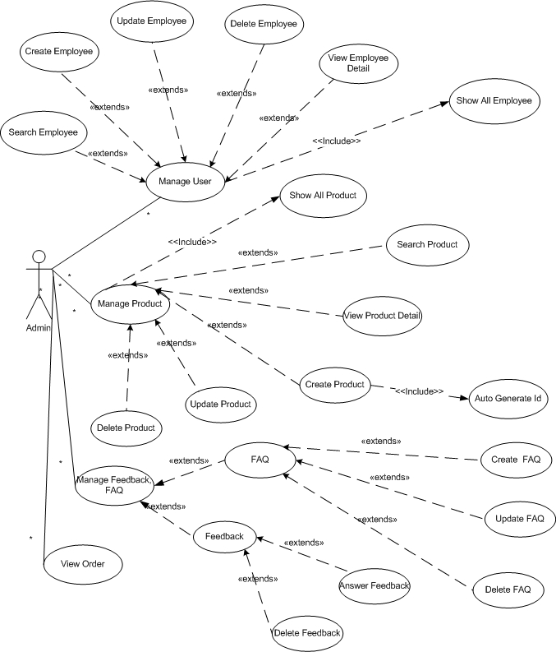
5.2 Admin:

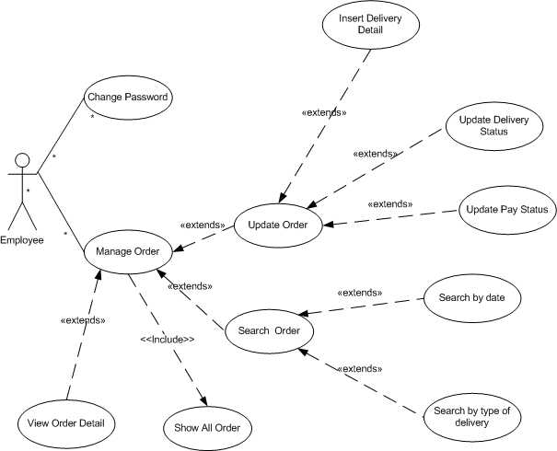
5.3 Employee

5.4 Registered Customer

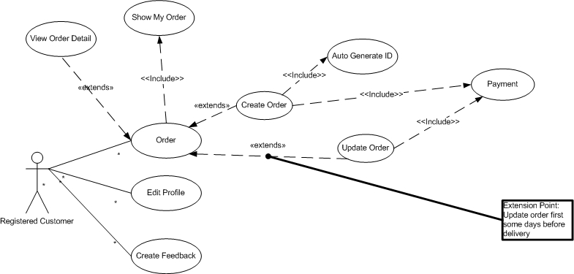

5.5 Unregistered Customer

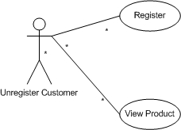
6. Process Flowchart

6.1. Login

Begin
End
Display
Login Page
Input
Username,
Password
User exists
Error
Message
Password
correct
Login
Successful

YES
YES
NO
NO

ADMIN

Login

Product
Master

m

D1
D2
D3
D1: Username, password
D2: D1
D3: + Login successful
+ Login fail

6.2 Log out

Begin
End

Log out
Display Login page

6.3. Change password

Begin
End
Display change password page
Input current password, new password
Current password correct
Error
Message

Change password successful

YES
NO

User
Change password

Product
Master

m

D1
D2
D3
D1: Current password, new password
D2: D1
D3: + Change successful
+ Change fail

6.4. Create Employee

Begin
End
Display Create employee page
Input ID, Name, Email, Address, Phone
ID
exists
Error
Message

Create employee successful

YES
NO

Admin
Create
Employee

Product
Master

m

D1
D2
D3
D1: ID, Name,Password,Email,…
D2: D1
D3: + Create successful
+ Create fail

6.5. Edit Profile

Begin
End
Display Edit employee page
Input ID, Name, Email, Address, Phone
ID
exists
Error
Message

Edit employee successful

YES
NO

User
Edit
Profile

Product
Master

m

D1
D2
D3
D1: Name, Email,…
D2: D1
D3: + Edit successful
+ Edit fail

6.6. Create New Campaign

Begin
End
Display Create new Campaign page
Input Campaign ID,Name,Object,
Estimated budget
Campaign ID exists
Error
Message

Create new Campaign Successful

YES
NO

Campaign
Master
Create
Campaign

Product
Master

m

D1
D2
D3
D1: Campaign ID, Name, Object,…
D2: D1
D3: + Create successful
+ Create fail

6.7. Update Campaign

Begin
End
Display Campaign Detail page
Input Campaign Name,Object,
Estimated budget
Campaign ID exists
Error
Message

Update Campaign Successful

YES
NO

Campaign
Master
Update
Campaign

Product
Master

m

D1
D2
D3
D1: Campaign Name, Object,…
D2: D1
D3: + Update successful
+ Update fail

6.8. Delete Campaign

Begin
End
Display Campaign Detail page
Campaign ID exists
Error
Message

Delete Campaign Successful

YES
NO

Campaign
Master
Delete
Campaign

Product
Master

m

D1
D2
D3
D1: ID
D2: D1
D3: + Delete successful
+ Delete fail

6.9. Create Product Category

Begin
End
Display Create Product Category page
Input Category ID,Name
Category ID exists
Error
Message

Create Product Category Successful

YES
NO

Campaign
Master

Create
Product
Category

Product
Master

m

D1: Product category name
D2: D1
D3: + Create successful
+ Create fail

6.10. Create Product

Begin
End
Display Create new Product page
Input Product ID,Name,Price
Product ID exists
Error
Message

Create new Product Successful

YES
NO

Product
Master
Create
Product

Product
Master

m

D1
D2
D3
D1: Product ID, Name,Price,…
D2: D1
D3: + Create successful
+ Create fail

6.11. Update Product

Begin
End
Display Product Detail page
Input Product new ID, Name, Price
Product ID exists
Error
Message

Update Product Successful

YES
NO

Product
Master
Update
Product

Product
Master

m

D1
D2
D3
D1: Product name, price,…
D2: D1
D3: + Update successful
+ Update fail

6.12. Delete Product

Begin
End
Display Product Detail page
Product ID exists
Error
Message

Delete Product Successful

YES
NO

Product
Master
Delete
Product

Product
Master

m

D1
D2
D3
D1: Product ID
D2: D1
D3: + Delete successful
+ Delete fail

8. Project Design

8.1 Database Design

a. Table Card Type

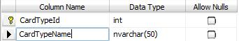

No. | Field Name | Description
01 | CardTypeId | ID of User
02 | Cart TypeName | Name of Card Type

b. Table Category

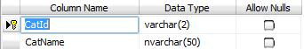

No. | Field Name | Description
01 | CatId
02 | CatName

c. Table Country

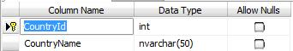

No. | Field Name | Description
01 | CountryId
02 | CountryName

d. Table Delivery Type

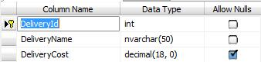

No. | Field Name | Description
01 | DeliveryId
02 | DeliveryName
03 | DeliveryCost

e. Table Feedback

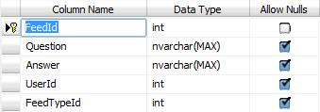

No. | Field Name | Description
01 | FeedId
02 | Question
03 | Answer
04 | UserId
05 | FeedTypeId

f. Table Feedback Type

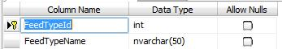

No. | Field Name | Description
01 | FeedTypeId
02 | FeedTypeName

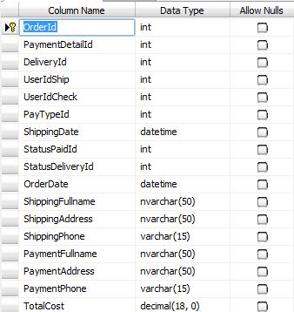
g. Table Order

No. | Field Name | Description
01 | OrderId
02 | PaymentDetailId
03 | DeliveryId
04 | UserIdShip
05 | UserIdCheck
06 | PayTypeId
07 | ShippingDate
08 | StatusPaidId
09 | StatusDeliveryId
10 | OrderDate
11 | ShippingFullname
12 | ShippingAddress
13 | ShippingPhone
14 | PaymentFullname
15 | PaymentAddress
16 | PaymentPhone
17 | TotalCost

h. Table Order Item

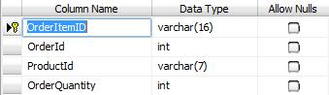

No. | Field Name | Description
01 | OrderItemId
02 | OrderId
03 | ProductId
04 | OrderQuantity

i. Table Payment Detail

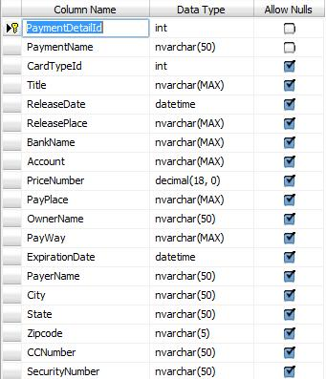

No. | Field Name | Description
01 | PaymentDetailId
02 | PaymentName
03 | CardTypeId
04 | Title
05 | ReleaseDate
06 | ReleasePlace
07 | BankName
08 | Account
09 | PriceNumber
10 | PayPlace
11 | OwnerName
12 | PayWay
13 | ExpirationDate
14 | PayerName
15 | City
16 | State
17 | Zipcode
18 | CCNumber
19 | SecurityNumber

j. Table Payment Type

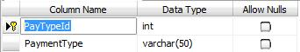

No. | Field Name | Description
01 | PayTypeId
02 | PaymentName

k. Table Product

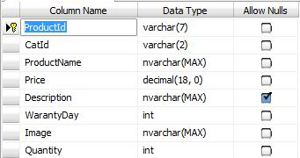

No. | Field Name | Description
01 | ProductId
02 | CatId
03 | ProductName
04 | Price
05 | Description
06 | WarrantyDay
07 | Image
08 | Quantity

l. Table Role
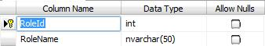

No. | Field Name | Description
01 | RoleId
02 | RoleName

m. Table Status Delivery

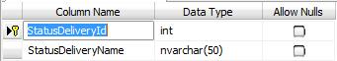

No. | Field Name | Description
01 | StatusDeliveryId
02 | StatusDeliveryName

n. Table Status Paid

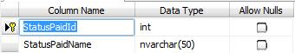

No. | Field Name | Description
01 | StatusPaidId
02 | StatusPaidName

o. Table Status User

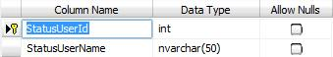

No. | Field Name | Description
01 | StatusUserId
02 | StatusUserName

p. Table Users

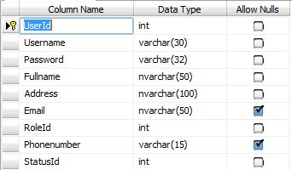

No. | Field Name | Description
01 | UserId
02 | Username
03 | Password
04 | Fullname
05 | Address
06 | Email
07 | RoleId
08 | Phonenumber
09 | StatusId

8.2 Entity Relationship Diagram (E-R Diagram)

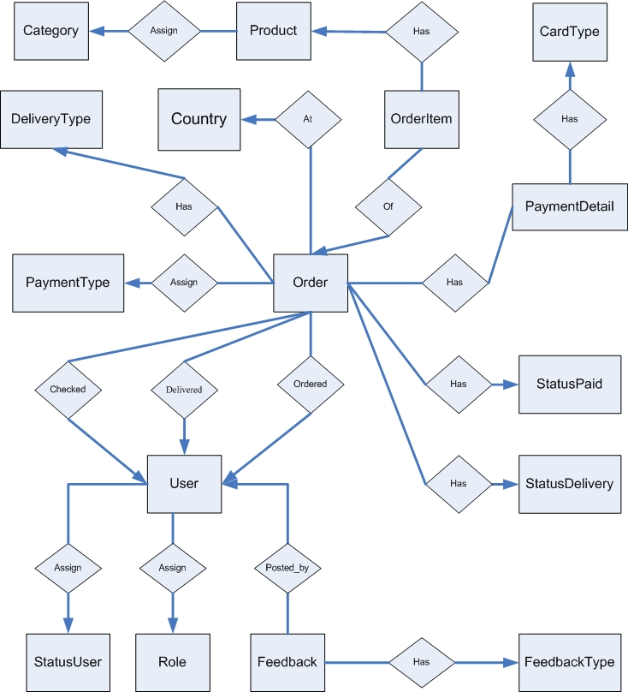

8.3. Class Object Diagram

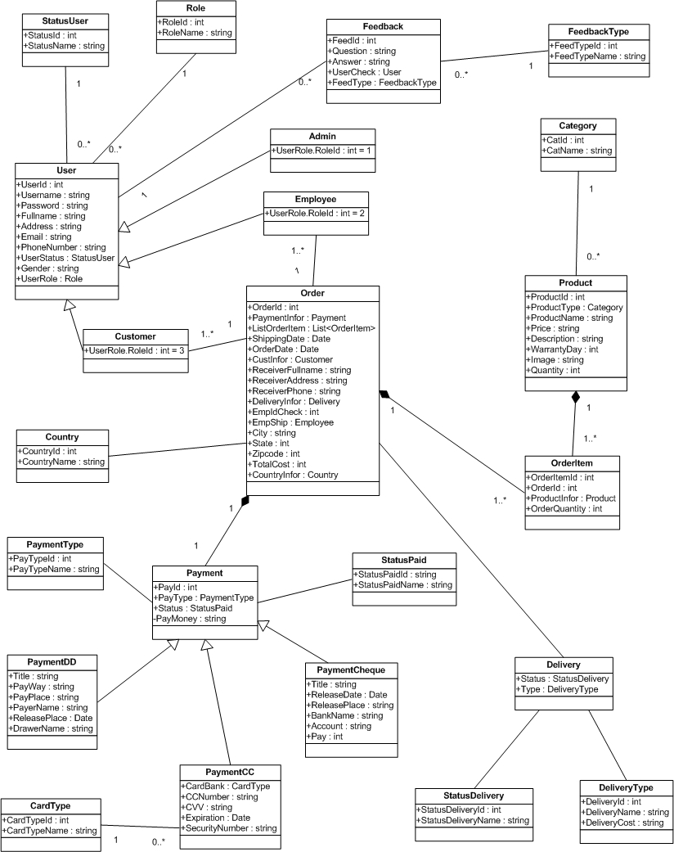

8.4 Table Diagram

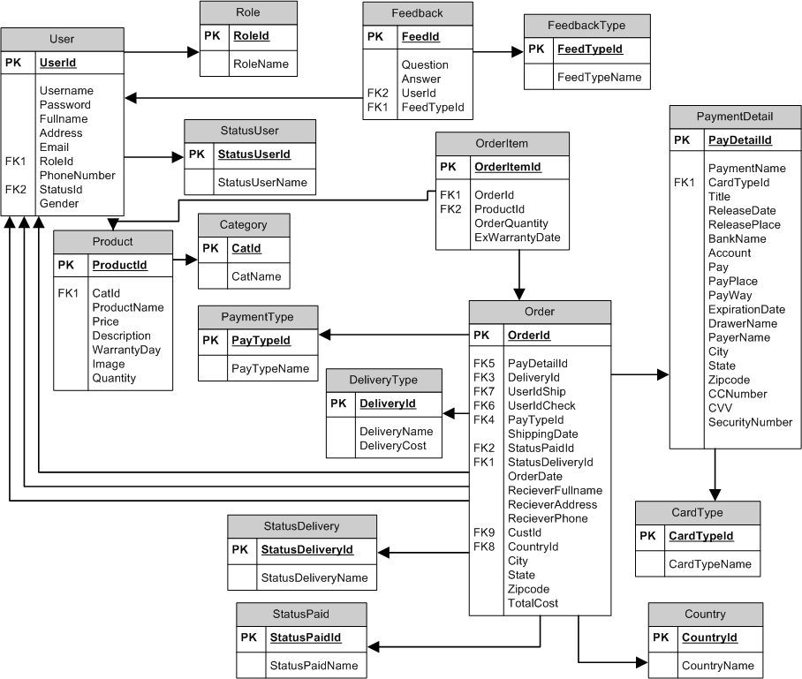

9. Interface Design Document

10. Task Sheet

 |  | Project Title | Activity Plan Prepared By: | Date of Preparation of Activity Plan:
No. | Task | Project Title | Activity Plan Prepared By: | Actual Start Date | Actual Days | Team Member Names | Status
 |  | OSC
 |  | OSC
 |  | OSC
 |  | OSC
 |  | OSC
 |  | OSC
 |  | OSC
 |  | OSC
 |  | OSC
 |  | OSC
 |  | OSC
 |  | OSC
 |  | OSC

11. Final Check List

11.1 Checklist of Validation

No. | Testing parameter | Validated (yes/no)
01 | Administrator can create a new user to enter the applications? | YES
02 | Distinguish users and administrators | YES
03 | User can change password | YES
04 | Campaign Master can create new Campaign in application | YES
05 | Product Master can create new Product in application | YES
06 | User can edit profile | YES
07 | Admin can export report | YES
08 | Campaign Master can create product category

11.2. Submission checklist

No. | Details | Yes | No | NA | Comment
01 | the users table to login the application after validation is performed on the user name and Password | Yes
02 | The application has icon in the title, button and menu | Yes
03 | the GUI of application friendly | Yes



Project Title : Campaign Information System

A. System Requirement

Sr. | Item | Description
1 | OS | Window XP
2 | Database | Microsoft SQL Server 2005
3 | Fonts | Unicode
4 | Programing Language | Java
5 | Editor | Eclipse

B. Installation Step

1. Install Microsoft SQL Server 2005
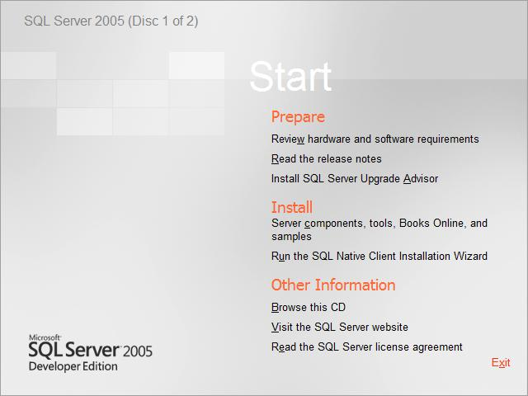

Click to install the “Server Component,tool,Books Online and samples”.

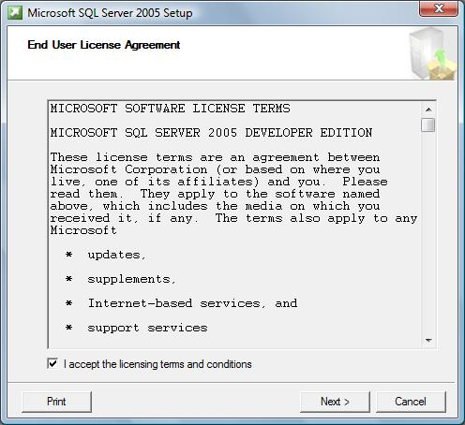

Accept the “End User License Agreement”. Click Next.

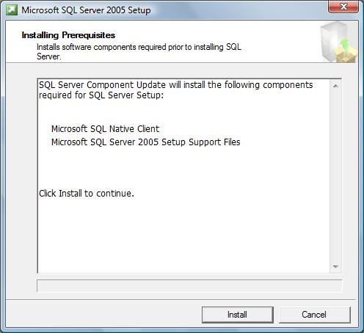

The Installing Perpetuates window will appear. Click Install

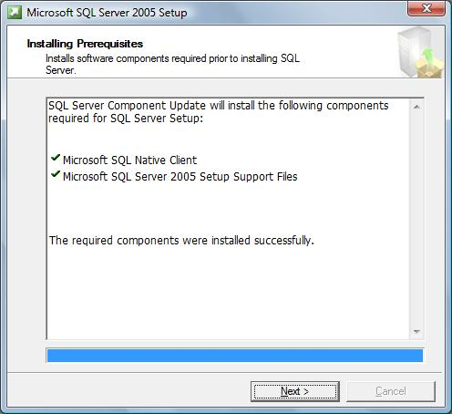

Then click Next to continue

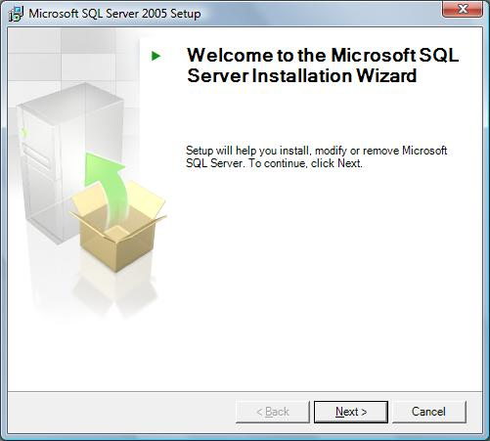

The SQL Server Installation Wizard will now appear. Click Next.
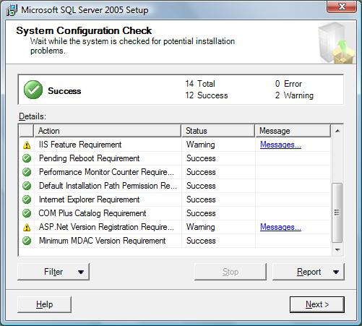

The System Configuration Check window will appear. The status of
each should indicate a status of “Success”. If everything checks out, click Next.

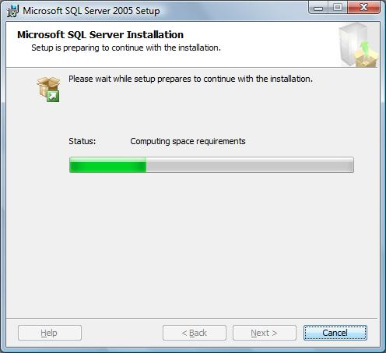

The SQL Server installation will begin to prepare the installation.
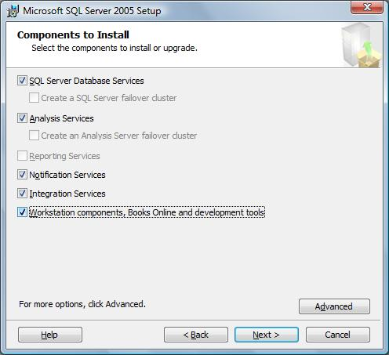

Check the followings boxes when the Components to install window appears.
Click Next when finished.

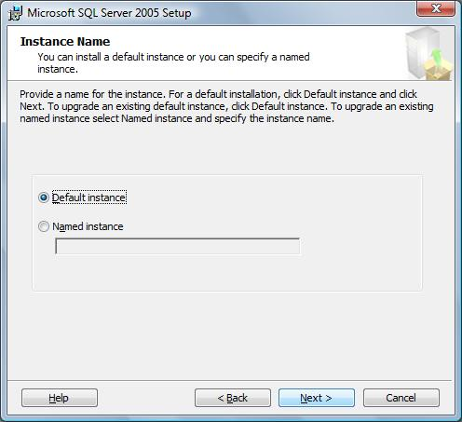

When the “Instance Name” window appears, be sure that
“Default Instance” is selected and click Next.

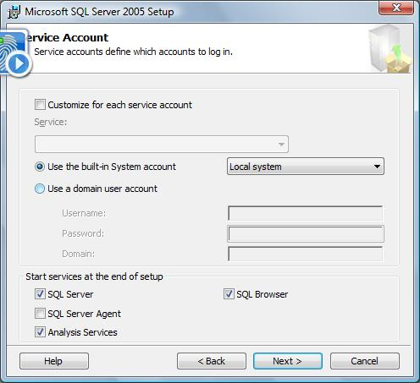

On the “Service Account” window, please select the option for “Use the built-in System account”. Be sure that “Local System” is selected. Click Next when finished.

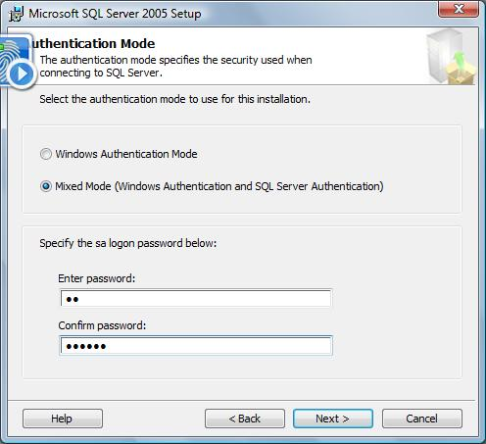

Select the “Mixed Mode” option on the “Authentication Mode” window.
At this point you may specify an sa logon and password: 123456.
Leave it blank. Click Next when finished.

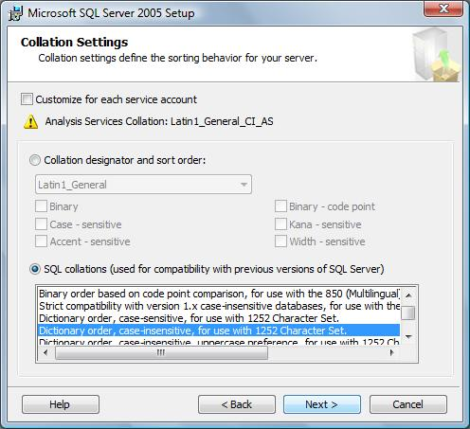

For the “Collation Settings” window, please select the option for “Dictionary order, case-insensitive, accent-insensitive, for use with 1225 Character Set”
. Click Next when finished.

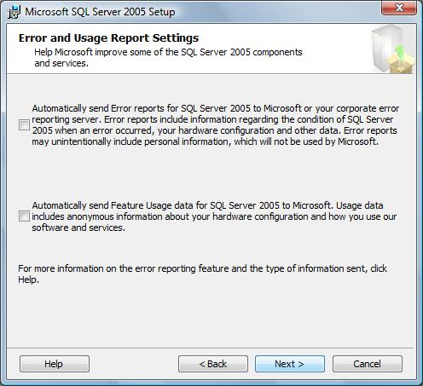

The Error and Usage Report Settings windows will appear, if you wish to send info to Microsoft, select each item, otherwise, please click Next to continue
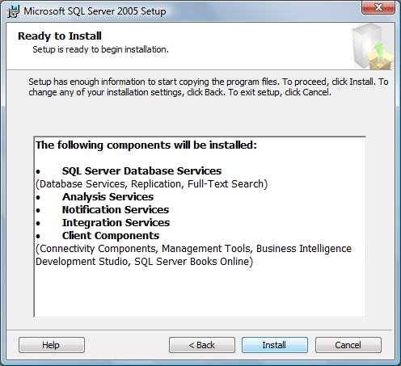

The Ready to Install window will appear. Review the components getting installed and click the Next button to continue.

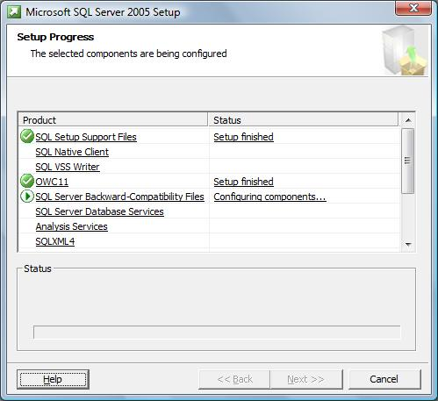

The “Setup Progress” window will appear. This will take several minutes to finish.
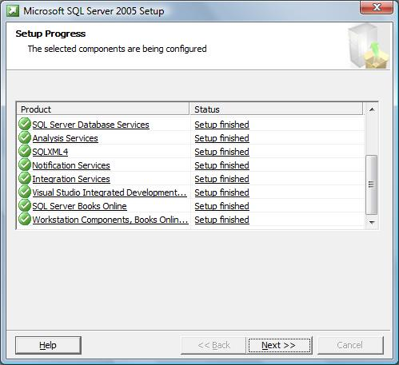

When the setup finishes, each status should indicate that the “Setup Finished”. Click Next to continue.
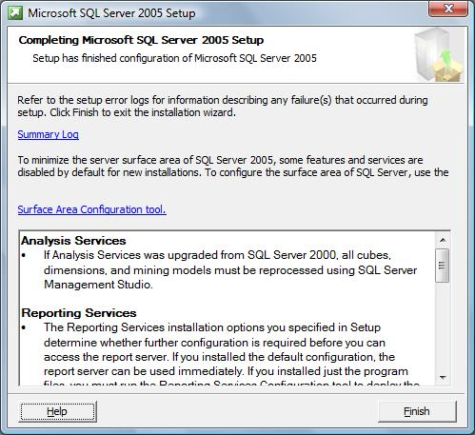

When completed, the “Completing Microsoft SQL Server 2005 Setup” window will appear. Review the services installed and click Finish.

2. Configuring MS SQL Server 2005:
To enable using application, you must config MS SQL Server 2005.At first, you configure “port”
-Select Start menu - Microsoft SQL Server 2005\Configuration Tools\SQL Server Configuration Manager
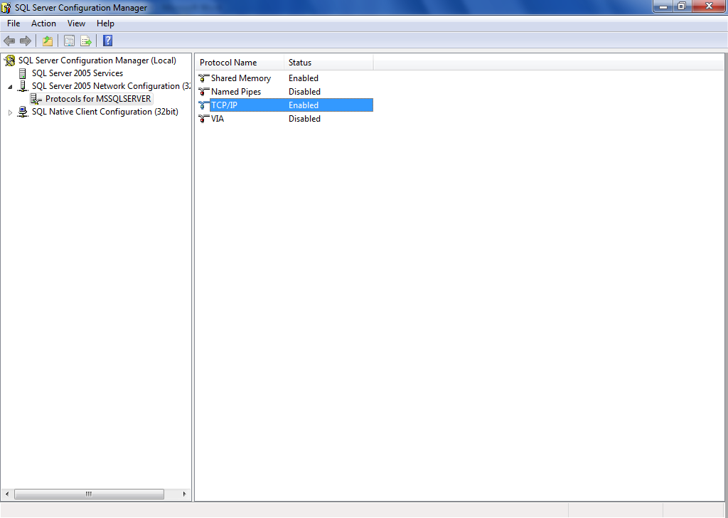

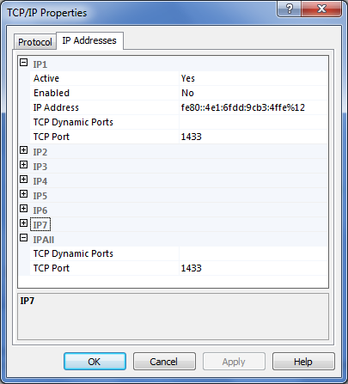

Set TCP Port : 1433
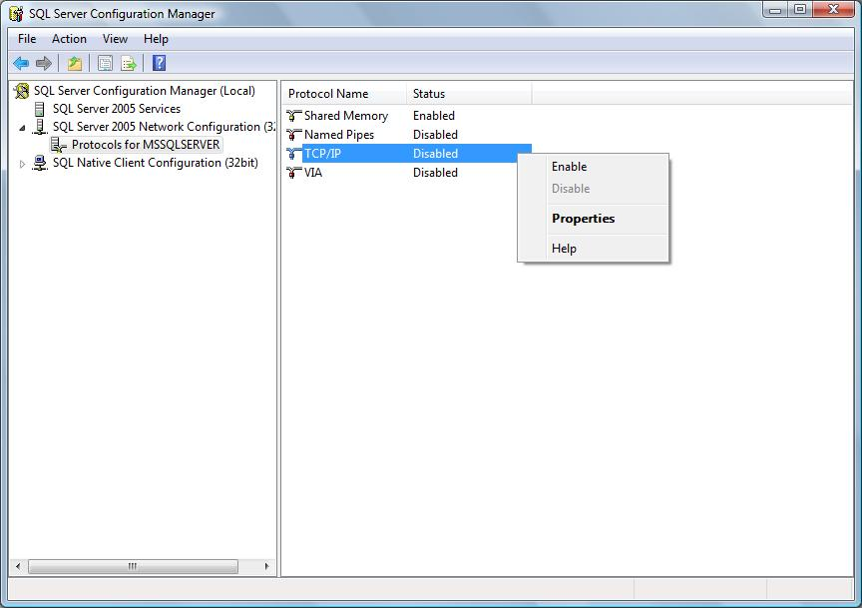

Right click on TCP/IP choose Enable
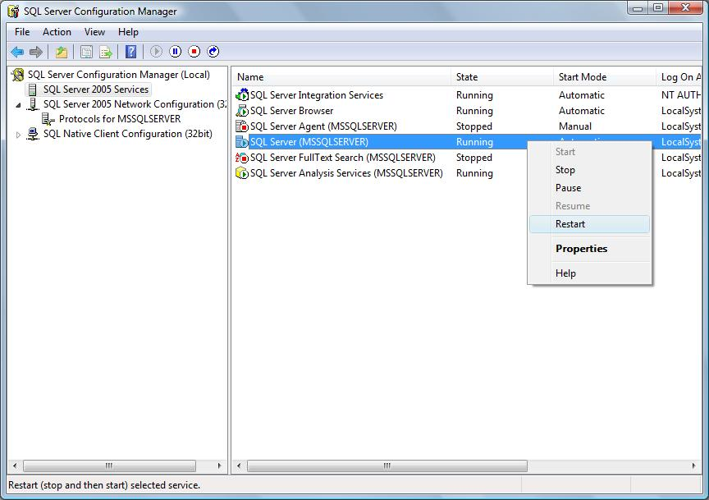

Choose SQL Server 2005 Services in left windows and right click on SQL Server (MSSQLSERVER) choose Restart

4. Setup Database

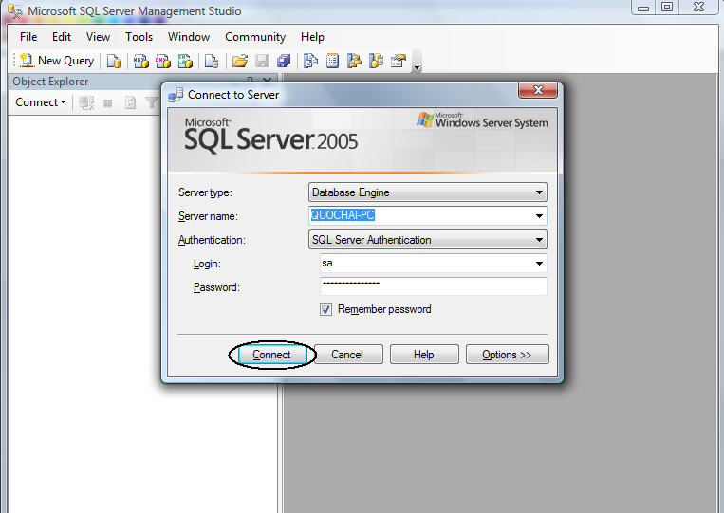

Field Authentication: choose SQL Server Authentication
Field Login: input “sa”
Field Password: input “123456”
Then click Connect
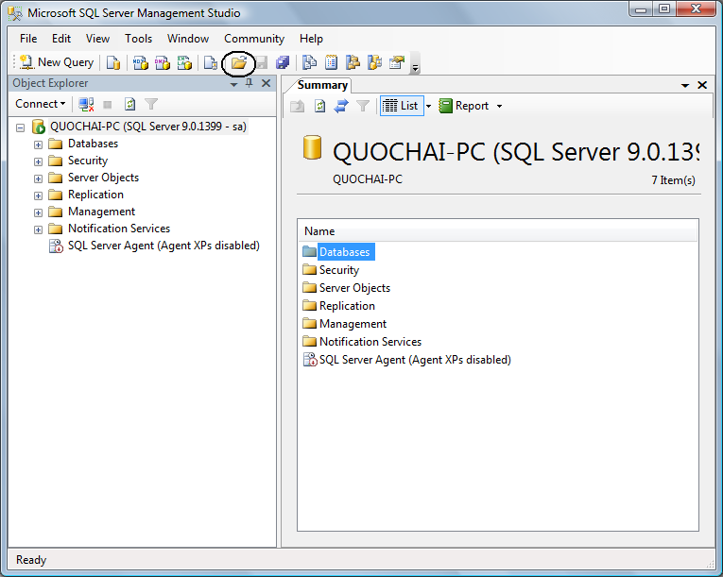

Press icon Open File or use Ctrl + O to open the file query

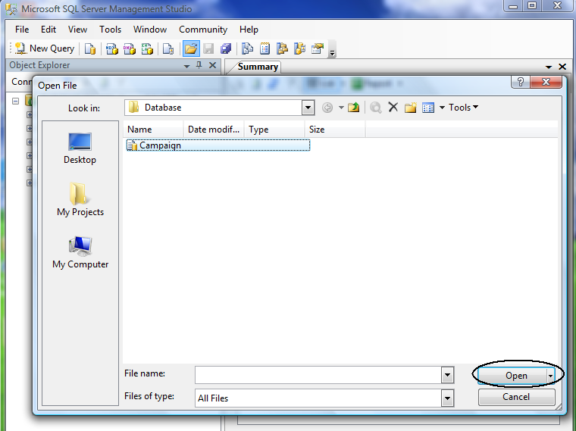

Browse to file SQL query in the project folder/Database/Campaign file
then click Open
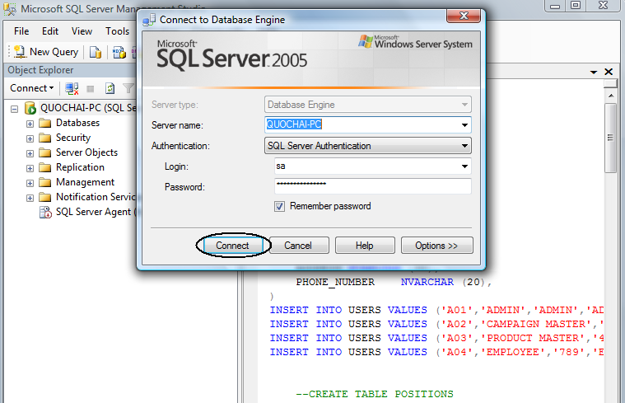

Click Connect to continue

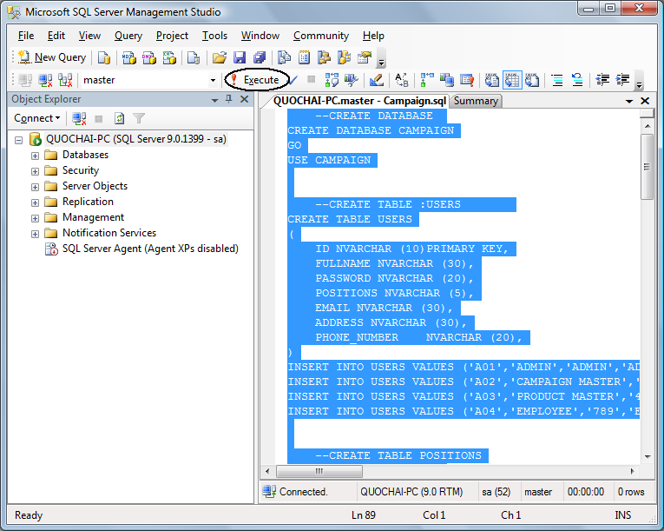

Select all (Ctrl +A) then press F5 or click Execute

5. Usage project

